x0x-heart Modifications
Philip Mease
Last modified Nov 06, 2016

Table of Contents
- Table of Contents
  - If you would like to contribute something to this area, simply contact us HERE and we'll get it posted to the site.
- Introduction
- Resources
- Hardware
  - Pots
  - Switches
- Calibration
- Increase Cutoff frequency range
- Decrease Tune Control Sensitivity
- VCF Reso Vol Dropout Fix (not tested) THIS IS ON THE THROUGH-HOLE BOARD!
- Increase Max Env Decay Amount
- Increase Max VCA Decay Amount
- Env Mod Amount
  - Increasing the range by ~2.5 times
- Resonance Boost
- Resonance Accent Range
- Bass Boost

If you would like to contribute something to this area, simply contact us HERE and we'll get it posted to the site.

Introduction
This is my resource for the modifications I've made to the x0x heart euro module (has pacemaker add on board).
Mods I have actually performed thus far are marked with pink colour. Most of the mods are carefully tweaked over several iterations to ensure the ranging of everything remains nice and usable. This means some changes could be more 'extreme,' if you personally wanted more.

Resources
x0xheart sch with MOD locations:
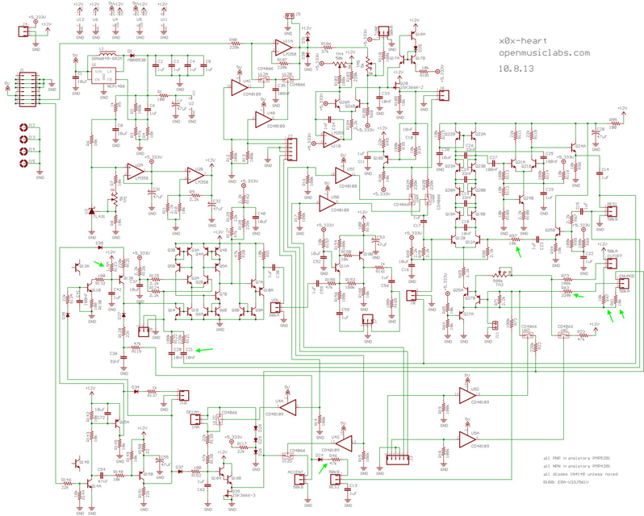
x0xheart sch: http://wiki.openmusiclabs.com/wiki/x0x-heart?action=AttachFile&do=get&target=p0x2_schem.png
x0xheart board: http://wiki.openmusiclabs.com/wiki/x0x-heart?action=AttachFile&do=get&target=p0x2_board.png
with MOD locations:
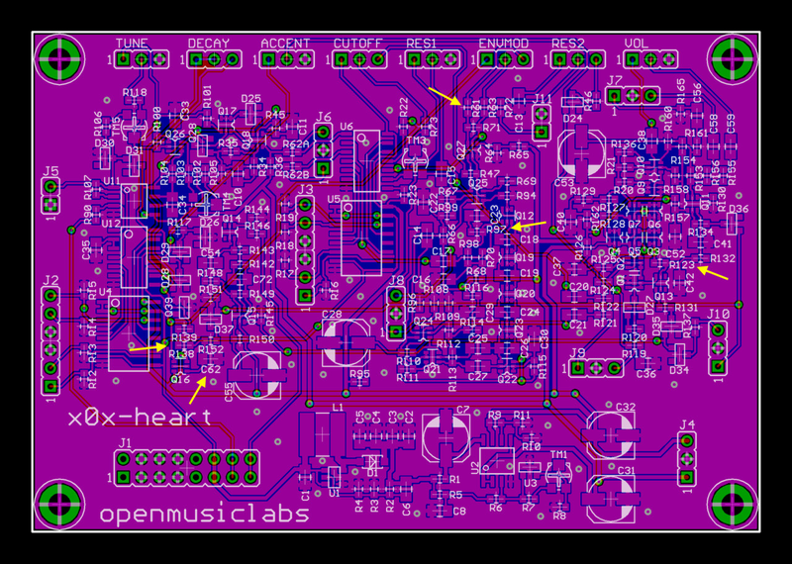
x0xbox sch: http://wiki.openmusiclabs.com/wiki/x0xb0x?action=AttachFile&do=get&target=mainboard2.png
'through hole board' pacemaker (for the Euro): http://wiki.openmusiclabs.com/wiki/EuroAdapter?action=AttachFile&do=get&target=pacemaker_sch.png
x0xheart user's manual: http://wiki.openmusiclabs.com/wiki/x0x-heart?action=AttachFile&do=get&target=x0xheartmanual.pdf
Some of the mods below are sourced and outlined here:
http://www.subatomicglue.com/x0xl0g/mod%20guide/mod%20guide.html#Increased_Filter_Low_End

Hardware

Pots
I'm using Bournes 3310-001 pots as they can be squeezed in the panel without much obstruction. And since most of these mods are set-n-forget (non-playable) we don't need rugged shaft pots; we'd rather have them not in the way! We can treat these just like trimmers.

Switches
Also need very small switches... using some crap I got from idk where. No clue a PN but they're the only thing that would fit. I mounted these on a 2mm pitch vector board and mounted the strip at each end to the two standoff locations above the UI board.

Calibration
TM3 adjusts filter cutoff freq offset... just look at x0xb0x manual for tuning procedures.

Increase Cutoff frequency range
Decrease R47. Some folks jumper this. NOTE: this will affect how low it can go (the default 10k limits pot end range) which is most useful to fully lower frequency to bring it in almost as if Fc was a volume control. Also for increased env. mod, you can set base starting freq lower.

Decrease Tune Control Sensitivity
This VCO is hard to tune. Tune knob is too touchy... decrease range.
Increasing R118 (it's 100k currently) should take care of this. Check tuning cal after this mod.

VCF Reso Vol Dropout Fix (not tested) THIS IS ON THE THROUGH-HOLE BOARD!
VCF mix - Another possible solution to the VCF amplitude problem is to adjust the VCF input mix. As the resonance is turned up, the amplitude of the VCF output drops. By mixing some of the signal from the resonance pot wiper, you can get an increase in signal as the resonance is turned up. A mix of 2:1 is used on the VCF output (same as is used internally in the 303 to feed the VCA). These are set with R30 and R34 (on the THB!!!). Dropping R30 to 100k from 220k gives a more consistent amplitude over the resonance range.
Checked PCB... already 100k in R30, R34 positions. Adding || 220k with R30 didn't seem to do anything noticeable. This is as good as it will get.

Increase Max Env Decay Amount
Increase C62 from 1uF to 1.5uF or so. Can also solder on top of existing SMD if you want. Use tantalum cap?
R138, 139 (total 69k), and the Decay pot (1MA) form the RC time constant for env decay. The CD4066 bypasses the pot (and just R138+R139 are left in series with C62) when accent is hit.
If you increase C62, the accent decay time will also increase... maybe reduce R138+R139 total to < 69k to compensate if you want to keep accent time the same.
I added switch which adds a 0.6875uF cap (1uF series w 2.2uF) in parallel with C62 when engaged to increase env mod decay time. I also replaced C62 with a 1uF 25V tantalum cap as per original.
NOTE: with this configuration, the accent wont always retrigger (when switch engaged for longer decay). There is not enough drive to turn it on fully due to the extra current required to build up the accent RC network. It may work with smaller parallel capacitance. Works fine with decay up (sounds good!) but also env mod dies a bit when you turn decay fully down. I am wondering if simply adding series R with the pot (it's in rheostat config) is the simpler solution. Can take R139, replace it with a higher value to set upper limit, then add a switched in || resistance for lower (normal) decays. This would alter both accent and non-accent decay. If you want it to leave the accent time alone, you'd have to add a series R with the pot. Maybe 500k more or so? Or maybe just a 1.5MA pot (that'd be hard to find though).
OK, added in the 500k in series with pot (it's switched)... works great. I would say just getting a 2MA pot would be the absolute shizzle as you wouldn't need the switch. The 500k resistor extends it by a decent amount (could be longer!!!) but going higher would mean minimum pot value is just too long. We'll keep it as is for now but ultimately we will want to find that special pot!
UPDATE: 2M audio taper pots are basically unobtanium. But! You can find dual 1M audio taper pots. Wire each section in series. I believe the guy I had laying around is a 16mm pot which will BARELY fit.
The 2M aud pot works GREAT!

Increase Max VCA Decay Amount
Is it the VCA or the ENV that's hitting first? I'd like longer sounds... try very long gate on signals to make sure it holds open before going through these mods.
R123 sets the decay of the VCA. subatomicglue recommends 1.5M total (1M pot, 500k series R) or 2M pot.
THis mod really isn't necessary for the x0xheart because you sequence it with gate signal anyway. The default 'release' time is fine as it is.

Env Mod Amount
Thanks to RobinWhittle of the DevilFish for posting these mods on his site.
Turning it all the way down
Remove R61 and replace it with a jumper wire. This will make it possible to turn the envelope modulation all the way down. If you want to make it switchable, leave R61 in place and solder a wire from each terminal of R61 to a switch. This will enable you to shorten out R61, much like replacing it with a jumper wire.
First test: Added switched short of R61
UPDATE: This ended up being nice but really, to make things easier/simpler and to make the knob range better, (no point to switching this switch midflight), R61 should just be replaced with a different value. R61 is 10k by default. Removed switch for this and just replaced R61 with a 3.3k resistor. Now knob doesn't go 'full off' for env mod (which is kinda pointless to remove env mod completely) but you gain a single control, sans switch and the control isn't too sensitive as it was when R61 was shorted out completely.

Increasing the range by ~2.5 times
I replaced 220k R63 with an 82k resistor.

Resonance Boost
You really don’t have to bother with anything but decreasing R97. Changing it to 5K or 6K is about as low as you would want to go, and definitely a switch to choose between the factory setting of 10K and the new hi-res would be a good idea.
I added switch for switching 15k in || with R97 for Req of 6k when engaged.
UPDATE: Changed parallel resistor to 27k for Req of 7.3k when engaged. Now when maxed, it can get loud but only at the absolute last bit of the reso pot.

Resonance Accent Range
Reduce or short out R46 to increase accent resonance.

Bass Boost
Change C21 and C20 from 0.01uF to 0.1uF. This should definitely be switched as you don't want to limit the lead capabilities of the 303. I would prefer to add cap in parallel (just in case switch takes a shit). Wire it such that the switch never opens the caps to avoid pops on charge of empty caps.

